**Supplementary material:**

**A six-mRNA prognostic model to predict survival in head and neck squamous cell carcinoma**

Saisai Tian1, Guofeng Meng2, Weidong Zhang1,2,\*

1 Department of Phytochemistry, School of Pharmacy, the Second Military Medical University, Shanghai 200433, P. R. China.

2 Institute of Interdisciplinary Integrative Medicine Research, Shanghai University of Traditional Chinese Medicine, Shanghai, P.R. China.

Correspondence: Weidong Zhang

Tel +86 021871 244

Fax +86 021871 244

Email wdzhangy@hotmail.com

**Supplementary Tables**

**Table S1. Clinical characteristics of HNSCC patients in TCGA.**

|  |  |  |  |
| --- | --- | --- | --- |
| **Characteristic** | **Training set** | **Testing set** | **Total** |
| **Age** |  |  |  |
| Median | 62 | 60 | 61 |
| Range | 24-90 | 19-88 | 19-90 |
| **Sex** |  |  |  |
| Male | 213 | 135 | 348 |
| Female | 74 | 55 | 129 |
| **Tumor Grade** |  |  |  |
| G1 | 40 | 21 | 61 |
| G2 | 178 | 118 | 296 |
| G3 | 67 | 51 | 118 |
| G4 | 2 | 0 | 2 |
| **Vital status** |  |  |  |
| Living | 125 | 83 | 208 |
| Dead | 162 | 107 | 269 |

**Table S2. The enriched KEGG pathways associated with six mRNAs**

|  |  |  |  |  |  |  |  |  |  |
| --- | --- | --- | --- | --- | --- | --- | --- | --- | --- |
| **ID** | **Description** | |  | | --- | | **setSize** | | **enrichmentScore** | |  |  | | --- | --- | | |  | | --- | | **NES** | | | |  | | --- | | **pvalue** | |
| hsa04020 | Calcium signaling pathway | 182 | 0.437 | 1.540 | 0.002 |
| hsa04022   |  | | --- | |  | | cGMP-PKG signaling pathway | 159 | 0.458 | 1.600 | 0.003 |
| hsa04151 | PI3K-Akt signaling pathway | 340 | 0.345 | 1.295 | 0.017 |
| hsa03030 | DNA replication | 36 | 0.514 | 1.433 | 0.044 |
| hsa04015 | Rap1 signaling pathway | 205 | 0.357 | 1.277 | 0.038 |
| hsa04668 | TNF signaling pathway | 110 | 0.406 | 1.348 | 0.030 |

**Supplementary Figures**

**Figure S1 The volcano plots of genomic genes.** The plot was constructed using fold-change values and padj-values. The vertical lines correspond to 2.0-fold up- and downregulation between tumor samples and nontumor samples in HNSCC, and the horizontal line represents a padj-value. The red points in the plot represent the differentially expressed mRNAs with statistical significance.

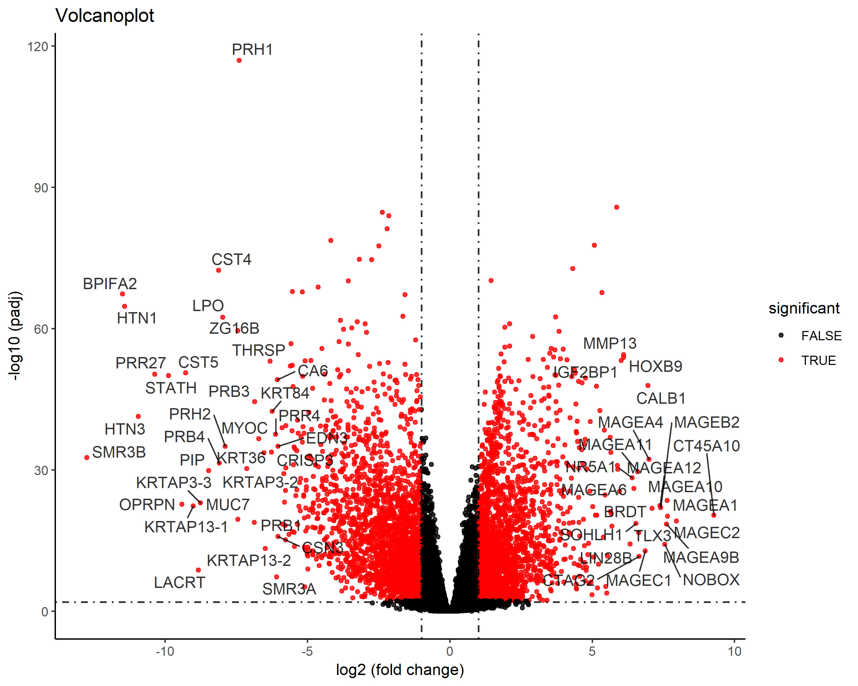

**Figure S2** **Samples clustering to detect outliers (entire dataset).** The clustering was based on the expression data of differentially expressed genes in HNSCC.

C:\Users\Administrator\Desktop\SR2\SR高清\fig2\cluster-01.tif

**Figure S3 Determination of soft-thresholding power in WGCNA.** (A) Analysis of the scale-free fit index for various soft-thresholding powers (β). (B) Analysis of the mean connectivity for various soft-thresholding powers. (C) Histogram of connectivity distribution when β=4. (D) Checking the scale free topology when β=4. (E) Dendrogram of all differentially expressed genes clustered based on a dissimilarity measure (1-TOM).

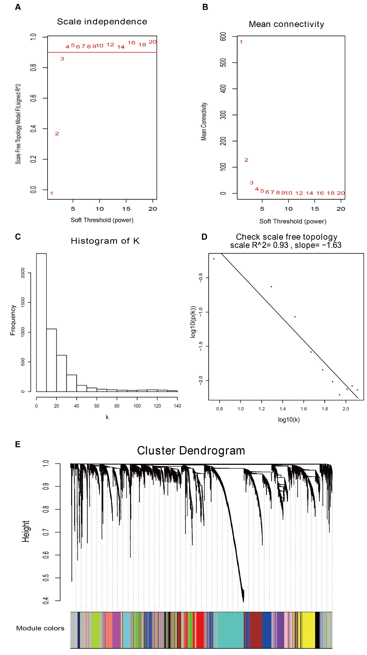

**Figure S4** **Selection of optimal tuning parameter  in the LASSO model.** The dotted vertical lines are drawn at the optimal values by minimum criteria (left) and 1-SE criteria (right). The optimal= 0.0810 was determined by ten-time cross-validation via minimum criteria. Error bars represent standard error (SE).

C:\Users\Administrator\Desktop\SR2\SR高清\lasso_1.tiff

**Figure S5**. **Construction of the six-mRNA signature model.** LASSO coefficient profiles of the 339 associated mRNAs. A vertical line is drawn at the value determined by 10-fold cross validation.

C:\Users\Administrator\Desktop\SR2\SR高清\lasso_2.tiff

**Figure S6 Kaplan-Meier survival analysis by X-tile plots cut-off point.** The plot shows the chi squared log-rank values created when the cohort was divided into two groups. The optimal cut-point highlighted by the black circle in the left panels is shown on a histogram of the training cohort (middle panels) and a Kaplan-Meier plot (right panels).

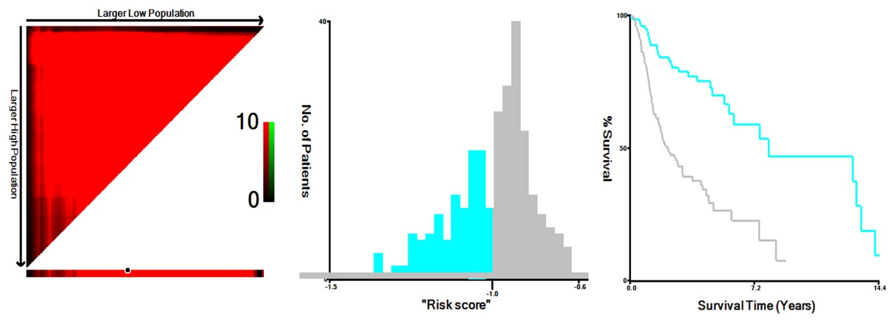

**Figure S7 The correlation between the expression levels of six mRNAs in the entire dataset and disease progression in HNSCC.** (A) FOXL2NB. (B) KCNJ18. (C) PCOLCE2. (D) RFPL1. (E) SPINK6. (F) ULBP2. Grade means histological grade.

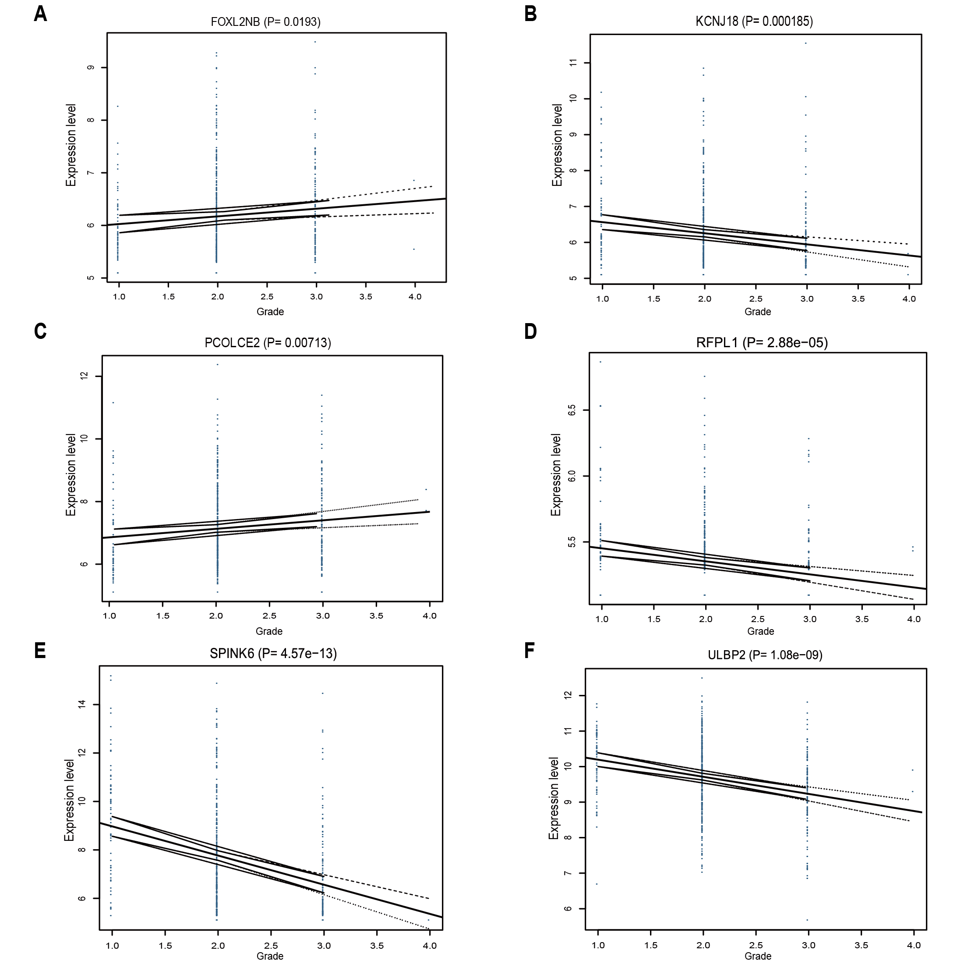

**Figure S8 Validation of the prognostic value of the six-mRNA signature in the test dataset and in the entire dataset.** The survival plot (upper panel), the 5-year survival ROC curve (2nd panel), risk score (3rd panel), survival information (4th panel) and z-score transformed expression value (top-down, FOXL2NB, PCOLCE2, SPINK6, ULBP2, KCNJ18, RFPL1) are shown for the test dataset (A) and the entire dataset (B).

